FALL 2022  
MEC325: INTRODUCTION TO ENGINEERING DESIGN  
DESIGN PROJECT  
**FINAL REPORT**

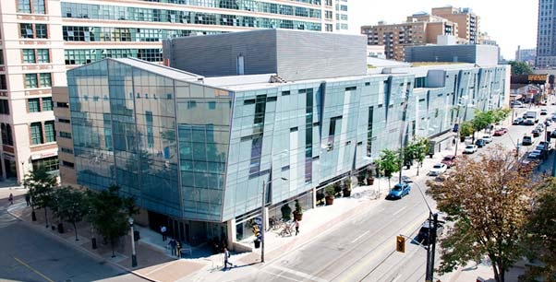

TITLE OF PRODUCT

TEAM SSNN

# table of contents

# team declaration

We, the undersigned members of Team SSNN in MEC325, agree that all team members have abided by all Ryerson Policies and course rules.

We furthermore accept that any violation of Ryerson Policy or course rules will lead to a grade penalty or charges of academic misconduct.

| STUDENT NAME | STUDENT NUMBER[1] |
| --- | --- |
|  |  |
|  |  |
|  |  |
|  |  |
|  |  |
|  |  |

# 

# 

# executive summary

# design brief summary

# background

# personas & SUCs

# requirements

# integrated design concept

# systems analysis

# detailed design

# design issues

# CAD drawings

# references

1. Only the last 5 digits of the student number are required.